**THE WATER CRISIS IN AFRICAN COMMUNITIES**

**A PHOTOGRAPHIC ESSAY**

**STEPHEN MBURU GATHIMA**

**C025-01-1869/2020**

**Table of content**

Contents

Introduction 3

**The Search for Water** 3

**Impact on Health** 4

**Innovative Solutions** 5

Education and Advocacy 6

**The Future of Water Security** 7

**Conclusion** 8

**References** 9

# Introduction

Water is a fundamental human need, yet millions of people across Africa face daily challenges in accessing clean and safe water. The scarcity of this vital resource has far-reaching impacts on daily life, health, and overall development in many African communities. This photographic essay aims to highlight the water crisis affecting these communities, showcasing the severe consequences and the remarkable resilience of those impacted by water scarcity. Through a series of powerful images, we will explore the struggles and the innovative solutions being implemented to address this critical issue.

# **The Search for Water**

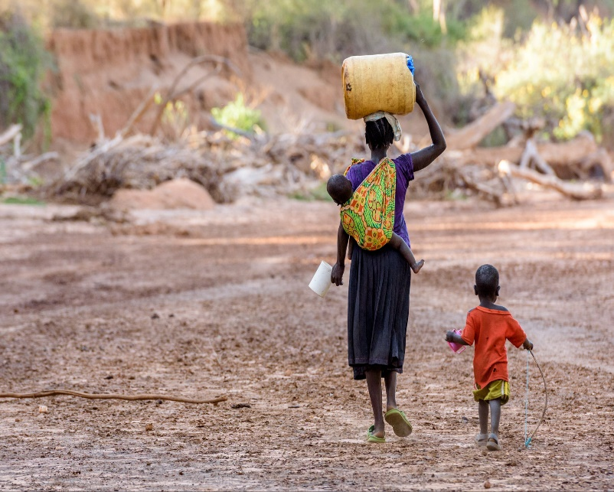 Women and children walk miles every day to fetch water from distant sources. This image shows a group of women and children walking along a dusty path, each carrying containers of various sizes, emphasizing the arduous journey undertaken daily.

In many African communities, the responsibility of fetching water falls predominantly on women and children. They often walk several kilometers to reach the nearest water source, a journey that consumes significant time and energy. This effort could otherwise be spent on education or economic activities, highlighting the daily struggle and sacrifice required to secure this basic necessity (WaterAid, 2023). The burden of water collection limits educational opportunities for children and economic participation for women, perpetuating cycles of poverty and inequality.

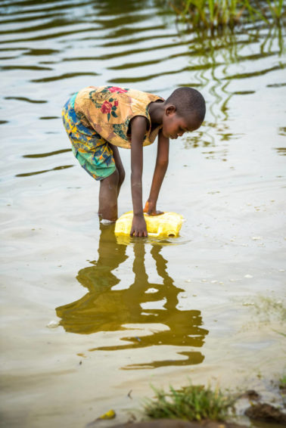 A young boy collects water from a muddy river. This image captures the reality of using contaminated water sources, highlighting the risks associated with waterborne diseases.

Due to the lack of access to clean water, many people resort to using unsafe water from rivers, ponds, or wells. These sources are often contaminated with bacteria, parasites, and other pollutants. This contamination leads to a high incidence of waterborne diseases such as cholera, dysentery, and typhoid, posing severe health risks to the community (World Health Organization [WHO], 2022). The reliance on contaminated water sources underscores the dire need for improved water infrastructure and sanitation facilities to prevent disease outbreaks and improve public health.

# **Kenya: Hundreds of lives saved as an innovative bead necklace helps diagnose pneumonia among children | Save the Children InternationalImpact on Health**

A mother comforts her sick child in a rural clinic. This image underscores the direct link between water scarcity and health, showing the human cost of waterborne illnesses. Waterborne diseases are a leading cause of mortality, especially among children under five. Clinics in rural areas are often overwhelmed by cases of diarrhea and other illnesses caused by contaminated water, straining limited medical resources and impacting overall community health (WHO, 2022). The high prevalence of these diseases exacerbates the healthcare challenges in rural areas, where medical facilities are often under-resourced and healthcare workers are overburdened.

# **Innovative Solutions**

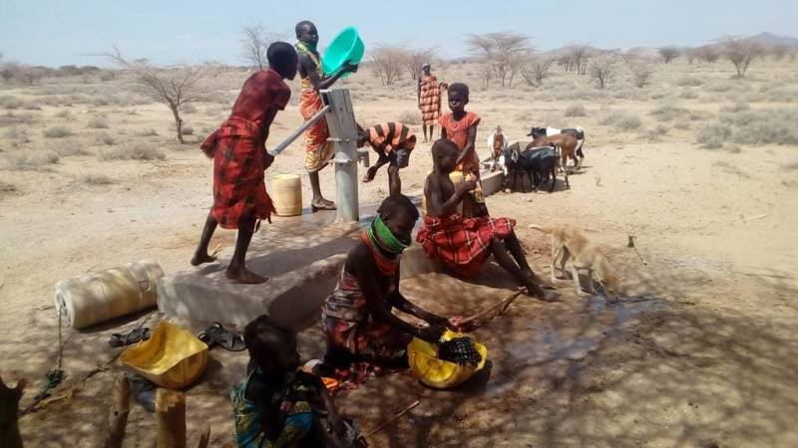

Community members work together to install a new borehole. This image highlights the collective efforts and innovative solutions being implemented to address the water crisis. Despite the challenges, many communities are taking proactive steps to improve their water situation. The installation of boreholes, rainwater harvesting systems, and water purification technologies are examples of how local and international efforts are making a difference (Global Water Institute, 2022). These solutions not only provide immediate relief but also promote sustainable water management practices that ensure long-term access to clean water.

# Empowering Communities: The Role of Education and Capacity-Building in Sustainable Water Management.Education and Advocacy

Children participate in a school program about water conservation. This image illustrates the importance of education and advocacy in promoting sustainable water use and hygiene practices.

**Description**: Education plays a crucial role in addressing the water crisis. Programs that teach children and communities about water conservation, hygiene, and sanitation can lead to long-term improvements in water management and health outcomes (United Nations, 2023). By empowering individuals with knowledge and skills, these educational initiatives foster a culture of sustainability and responsibility, essential for tackling water scarcity.

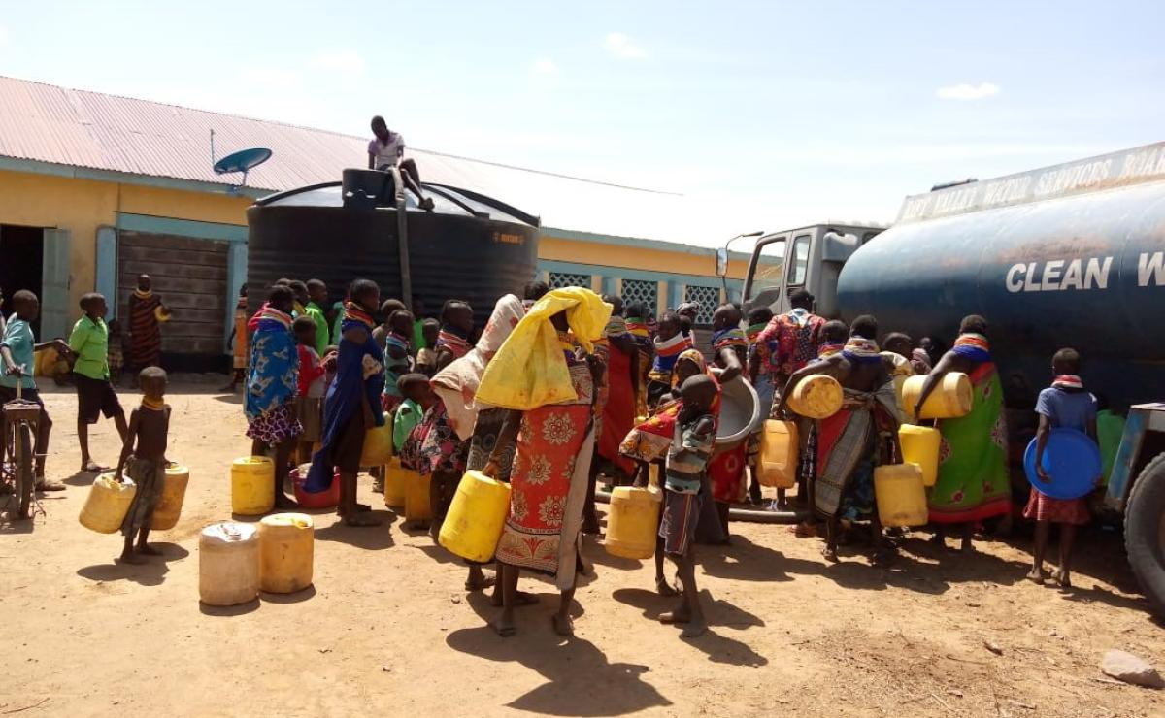**The Role of Women**

**Caption**: A woman proudly stands next to a newly constructed water tank in her village. This image celebrates the role of women in leading water-related initiatives and driving community change.

Women are often at the forefront of efforts to secure and manage water resources. Their leadership and participation in water projects are vital for ensuring sustainable and equitable access to water for all community members (WaterAid, 2023). By involving women in decision-making processes and implementation of water projects, communities can benefit from diverse perspectives and more effective solutions to water scarcity.

# **The Future of Water Security**

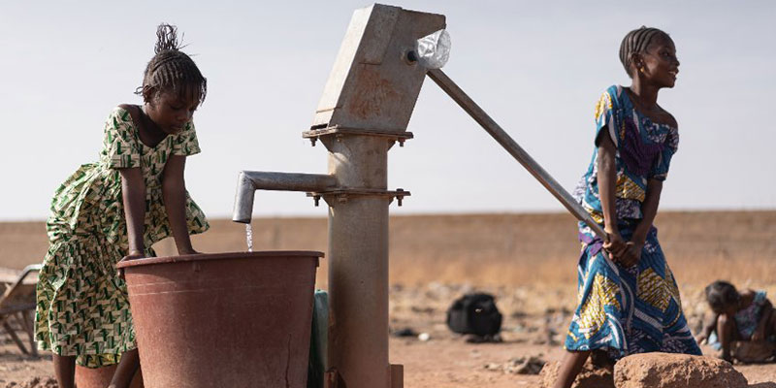A child drinks clean water from a tap, a symbol of hope and progress. This image represents the ultimate goal of achieving water security for all.

Ensuring access to clean and safe water is essential for the future development and well-being of African communities. Continued investment in water infrastructure, education, and community engagement is necessary to overcome the challenges and secure a better future for all (African Development Bank [AfDB], 2023). By prioritizing water security, communities can achieve improved health, economic development, and social stability.

# **Conclusion**

The water crisis in African communities is a complex and pressing issue that affects millions of people. Through these photographs, we have seen the daily struggles, health impacts, and the remarkable resilience of those affected. The images have highlighted the critical need for clean water and the innovative solutions being implemented to address this issue. By raising awareness and promoting solutions, we can work towards a future where access to clean water is a reality for everyone. Addressing the water crisis requires a multifaceted approach, involving investments in infrastructure, education, and community engagement to ensure sustainable and equitable access to this essential resource.

# **References**

United Nations. (2023). *Water scarcity*. Retrieved from https://www.unwater.org/water-facts/scarcity

World Health Organization. (2022). *Drinking-water*. Retrieved from <https://www.who.int/news-room/fact-sheets/detail/drinking-water>

WaterAid. (2023). *The water crisis in Africa*. Retrieved from https://www.wateraid.org/where-we-work/africa

Global Water Institute. (2022). *Innovative solutions to water scarcity in Africa*. Retrieved from https://www.globalwaterinstitute.org/solutions/africa

African Development Bank. (2023). *Water and sanitation in Africa*. Retrieved from https://www.afdb.org/en/topics-and-sectors/sectors/water-supply-sanitation